Logging data to DB
- Switch solution to full mode
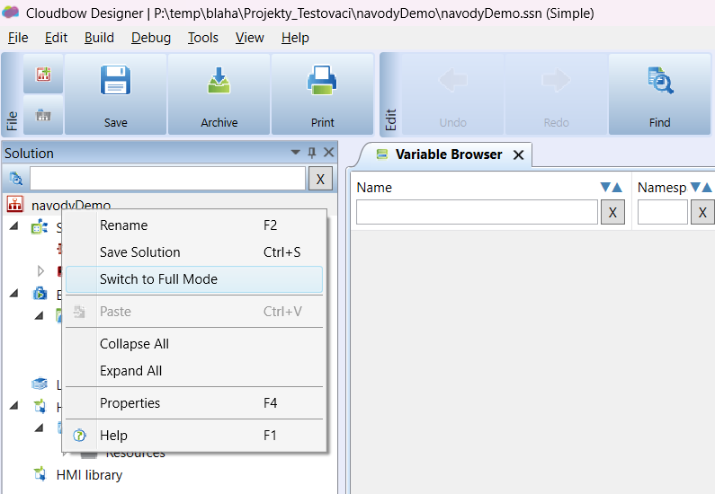
- Add new history
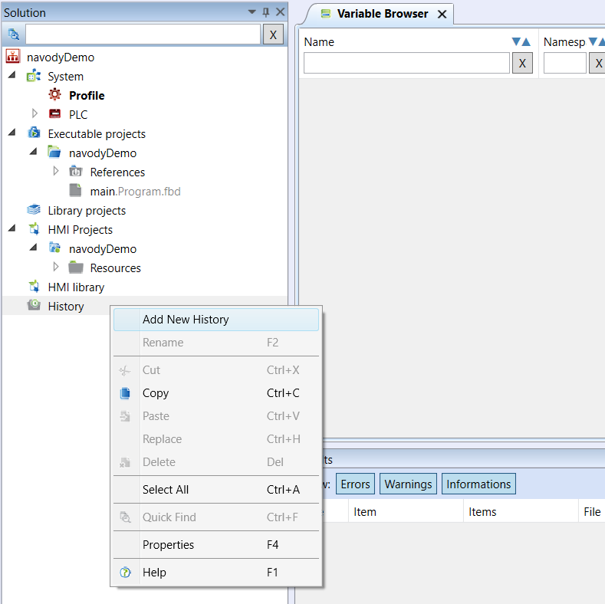
- In history properties enable History Saved on PLC and set Save Period (How often the variable values will be stored in the history).
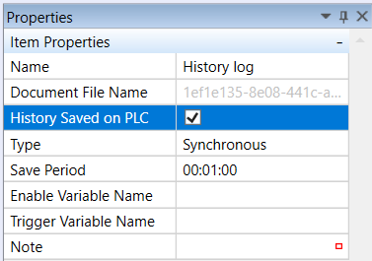
- In a variable browser select variables you want to store in DB. Then right click and Add to History.
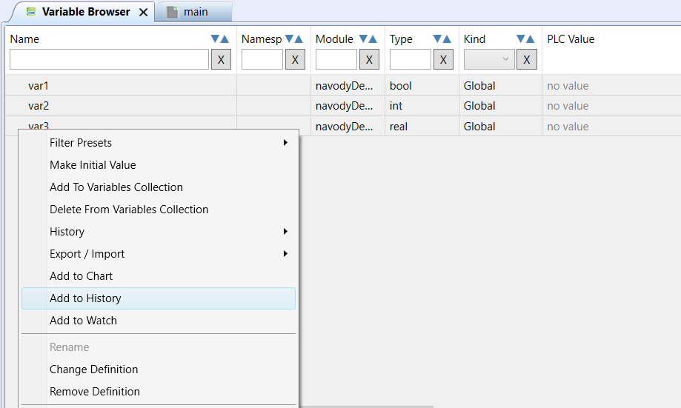
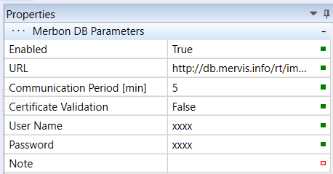
- In the PLC properties in the Merbon DB Parameters section, enable saving to DB. To the URL add “http://db.mervis.info/rt/imports2/save”. Set in minutes how often the data will be sent to the DB. Fill your Username and Password.

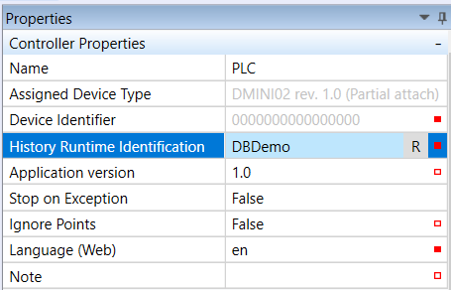
- In the PLC properties in the Controller Parameters section fill History Runtime Identification. Use a unique identifier. PLC can be found in the database under this identifier.

- Upload configuration to the PLC. Then the PLC should send selected data to DB.

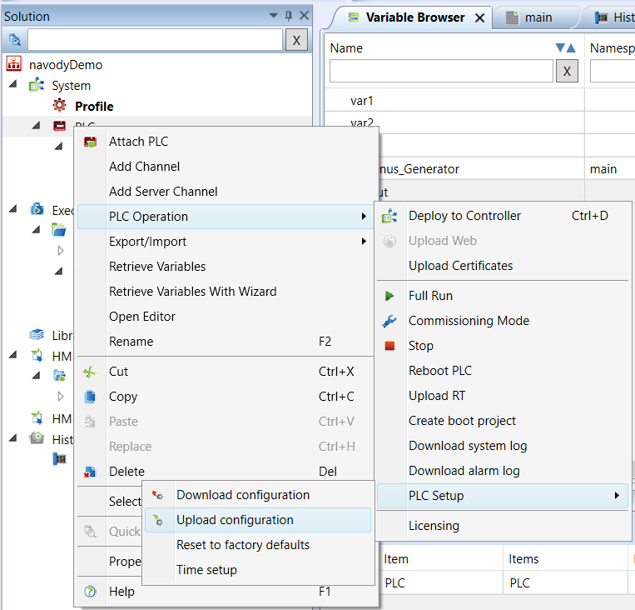

- To view the data in the database, go to the link: https://db.mervis.info/viewer2/#/graphView"
To URL fill “https://db.mervis.info/db/imports2/RcWareDbAccess “ and enter your username and password. Enter " SoftPlcRtId " in the Key field and fill field Value with your History Runtime Identification. Then click to Set and Close.
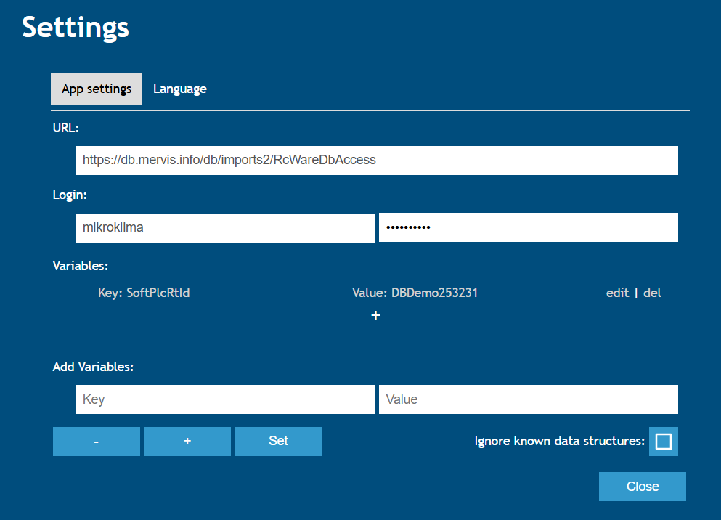

- Now you just need to select the variables you want to display and then you should see them in the charts.
